HAIR/ACCESSORIES/TIGHTS/SHOES FOR RECITAL (and Dress Rehearsal)

CLASS | DANCE | HAIR | ACCESSORIES | TIGHTS | SHOES | OTHER NOTES
Monday  Lyrical/Jazz 2 | Supermodel | High curly ponytail | As provided | Tan fishnets provided | Tan jazz shoes | Flesh tone seamless briefs if desired
Monday  Tap 2 | When You’re Smiling | High curly ponytail | As provided | Tan fishnets provided | Black tap shoes | Flesh tone seamless briefs if desired
Monday  Ballet 4-5-6 | The Gallery Awakens | Center part into low bun | As provided | Ballet pink provided | Pink canvas, split sole | Flesh tone seamless undergarments may be worn if desired
Tuesday  Ballet/Tap/  Jazz 1.5 | Photo Booth | High curly ponytail | As provided | Tan fishnets provided | Tan jazz shoes
Tuesday  Little Jamz  Hip-Hop | Polaroid Picture | High curly ponytail | As provided | None | Solid white athletic | No show socks. Double knot laces
Tuesday  Hip-Hop 2-3 | Strike a Pose | Center part into low bun | As provided | None | Solid white athletic | No show socks. Double knot laces
Tuesday  Hip-Hop 4 | Video Phone | Center part into low bun | Hair scrunchy | None | Solid white athletic | No show socks. Double knot laces
Wednesday  Itsy Bitsy Ballet | Pretty As A Picture | High bun | As provided | Ballet pink provided | Pink ballet shoes | No underwear, please
Wednesday  Hip-Hop 2-3 | Paparazzi | High curly ponytail | As provided | None | Solid white athletic shoes | No show socks. Double knot laces. Flesh toned bra if needed
CLASS | DANCE | HAIR | ACCESSORIES | TIGHTS | SHOES | OTHER NOTES
Wednesday  Ballet/Tap/Jazz 1 | Shadows and Light | High bun | As provided | Ballet pink provided | Pink canvas, split sole | No underwear please
Wednesday  Contemporary/  Improv 3 | Pictures of You | Center part into low bun | As provided | None | None | Flesh tone seamless undergarments may be worn if desired
Wednesday  Ballet 2 and 3 | Tangled | Center part into low bun | As provided | Ballet pink provided | Pink canvas, split sole | Flesh tone seamless undergarments may be worn if desired
Thursday  Broadway Babes | Vogue | High curly ponytail | White glove, fascinator. Use lots of pins! | Tan fishnets provided | Tan jazz shoes | Flesh tone seamless undergarments may be worn if desired
Thursday  Contemporary/  Improv 4 | Golden Hour | Center part into low bun | As provided | None | None | Flesh tone seamless undergarments may be worn if desired
Thursday  Tap 4 | Photoshop | Center part into low bun | As provided | None | Black tap shoes, double knot laces! | Flesh tone seamless bra/briefs highly recommended
Grand Finale | Freeze Frame | Last style performed in | None | None | Tan jazz shoes | Flesh tone seamless undergarments may be worn if desired

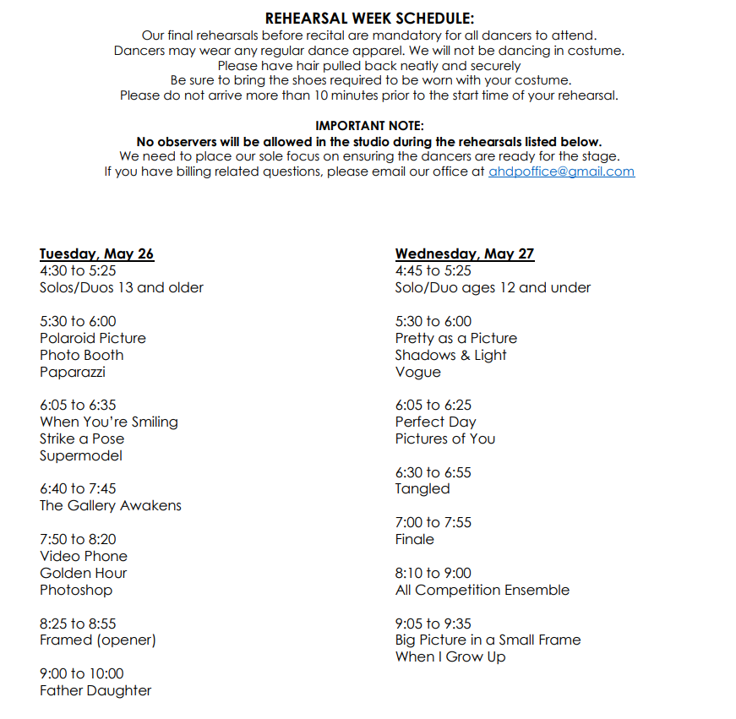

AHDP 2026 PICTURE DAY SCHEDULE
THURSDAY, MAY 28TH
Pictures are taken at AHDP

We are happy to welcome Faustina Steinman to photograph each class and individual in recital costumes
Please be sure to review the picture day instructions on page 2 of this document!
PICTURE DAY SCHEDULE
Doors open at 2:30
Arrive with time to change into costume
Photo READY Time | Dance Title | Class
3:00 | Big Picture in a Small Frame CENTER PT LOW BUN | Lyrical 5-6 (Thurs)
3:15 | When I Grow Up CENTER PART LOW BUN | Advanced Tap (Tues)
3:35 | Golden Hour LOW BUN | Contemp/Improv 4 (Thurs)
3:50 | Video Phone LOW BUN | Hip-Hop 4 (Tues)
4:05 | Photo Shop LOW BUN | Tap 3-4 (Thurs)
4:20 | Pictures of You LOW BUN | Contemp/Improv 3 (Weds)
4:35 | Strike a Pose LOW BUN | Hip-Hop 2-3 (Tues)
4:55 | Paparazzi LOW BUN | Hip-Hop 2 (Weds)
5:10 | Pretty as a Picture HIGH BUN | Itsy Bitsy Ballet (Weds)
5:25 | Vogue HIGH CURLY PONYTAIL | Broadway Babes (Thurs)
5:40 | Shadows & Light HIGH BUN | B/T/J 1 (Weds)
6:00 | Polaroid Picture HIGH CURLY PONYTAIL | Little Jamz (Tues)
6:20 | When You’re Smiling LOW BUN | Tap 2 (Mon)
6:35 | Photo Booth HIGH CURLY PONYTAIL | B/T/J 1.5 (Tues)
6:50 | Supermodel LOW BUN | Lyrical/Jazz 2 (Mon)
7:05 | Tangled CENTER PART LOW BUN | Ballet 2 & 3 (Weds)
7:40 | The Gallery Awakens CENTER PART LOW BUN | Ballet 4, 5, 6 (Mon)
Anticipated End Time: 8:30

